NIEMOpen Project Governing Board (PGB) MEETING MINUTES
Date/Time: 28 August 2025
Location: Virtual Meeting MS TEAMS
Chair: Ms. Katherine Escobar
OASIS Administrators: Ms. Kelly Cullinane
Recorders:
- Ms. Shunda Louis, (shunda.r.louis.ctr@mail.mil)
Mr. Stephen Sullivan, (stephen.m.sullivan14.ctr@mail.mil)

- Goal: The goal of the 28 August 2025 PGB meeting was:
- Nomination and Election of new Chair (s)
- Discuss NMO Transition
- Install new Chair (s)
- Funding requests for:
  - 8 Oct Leadership Meeting
- Discuss future business.

- A YouTube video of the PGB meeting is not available.

- List of Attendees:
# | Attendees | Role
1 | Jim Herbert (APN) | PGB Voting Member
2 | Erica Smith (BJS) | PGB Voting Member
3 | Katherine Escobar (Joint Staff J6, DSD) | PGB Voting Member
4 | Christina Bapst-Stump (DHS S&T) | PGB Voting Member
5 | Mark Dotson (GTRI) | PGB Voting Member
6 | Paul Wormeli (IJIS) | PGB Chair
7 | April Michell (FBI/CJIS) | PGB Voting Member
8 | Erin Partin (NIJ) | PGB Voting Member
9 | Scott Renner (MITRE/NTAC Co-Chair) | PGB Expert Voting Member
10 | Brad Bolliger (EY/NTAC Co-Chair) | PGB Expert Non-Voting Member
11 | Kelly Cullinane (OASIS) | OASIS Senior Director of Standards Development
12 | Maria Cardiellos (IJIS) | member
13 | Kamran Atri (A4SAFE, NBAC Tri-Chair) | PGB Expert Non-Voting Member
14 | Jim Cabral | member
15 | Cathie Mayo (OASIS) | OASIS CFO
16 | Rita Petti (OASIS) | OASIS Director of Business Development and Partnerships
17 | Stephen Sullivan (Joint Staff J6, DSD/BAH) | Meeting Recorder
18 | Shunda Louis (Joint Staff J6, DSD/BAH) | Meeting Recorder

Quorum: 9 of 12 PGB Voting/Expert Voting Members attended.
- Agenda:
Call to Order
Admin
- Call to Order
  - TEAMS Link
  - Roll Call & Introductions
    - Sponsor Appointed PGB Voting Members (Sponsors)
    - PGB Expert Voting Members (TSCs) & Non-Voting Members (TSC Co-Chairs)
- Approval of Agenda
- Announcements
- Election of New Chair, NMO Task Transition – Big Picture
Motions
- Motion to nominate & elect new PGB Chair (s).
- Motion to approve 29 May Minutes
- Motion to authorize $ 2000 for 8 October NPC Leadership Meeting.
- Motion to approve PGB Meeting dates.
BREAK
Other Business
- Around-the-Horn – PGB Voting Member Comments/Questions
- 2025 OASIS Staff / NIEMOpen Administrator
- Q2 2025 Financial Snapshot – Cathie Mayo (OASIS)
- Sponsor Update – Rita Petti/ Holly Peterson
- CY 2025 Tasks
- NIEM.gov Migration – Aubrey Beach
- 8 Oct NPC Meeting Update
- 13 Nov Reveal Summit Webinar Update

Co-Chair Discussion/Updates
- NTAC Update – Mr. Brad Bolliger & Dr. Scott Renner
- NBAC Update – Thomas Krul
- Next Meeting Schedule
- Other Business/Discussion
- Questions/Adjourn

- Motions:

Motions | Description | Vote | Notes
8/28 Nominate and elect a new PGB Chair | (Katherine Escobar-Chair) Motion to nominate and elect | Approved, 9 approved | Full Majority Vote: “Full Majority Vote” is a vote in which more than 50% (more than half) of the eligible voter's vote “yes.” If the vote is held in a committee meeting, more than 50% of the total eligible voters must vote “yes” regardless of the number of present. Abstentions are not counted- https://www.oasis-open.org/policies-guidelines/oasis-defined-terms-2018-05-22/#dFullMajority
8/28/25 -Approve 30 Jan 2025 PGB Meeting Minutes | (Paul Wormeli-Chair) Motion to approve | Approved, 8 approved
8/28/25 – $ 2000 for Support Services for NIEMOpen Leadership Meeting at NPC. | (Paul-Wormeli) I motion that $ 2000 from the NIEMOpen general fund originally approved for the Reveal Summit be authorized for the October event and the remainder (~$4000) be returned to the general fund. | Approved, 8 approved | In May, the PGB approved $ 6000 from the NIEMOpen general fund for refreshments, snacks, swag and AV services for the NIEMOpen Reveal now scheduled for 13 November as a Webinar.  The NPC location (sunk cost) was retained for a Leadership and general member meeting on the 8th of October. The Reveal funds no longer required; this motion request a portion of those funds (not to exceed $2K) be applied to the 8 October NPC event.
8/28/25 Q4 2025 & CY 2026 PGB Meeting Dates | (Paul-Wormeli-Chair) Motion to moving the 13 November 2025 PGB meeting to 4 December 2025 and establish the CY 2026 Q 1, 2, 3 & 4 PGB Meeting Dates was submitted as a readahead to PGB Voting Members. | Approved, 8 approved | 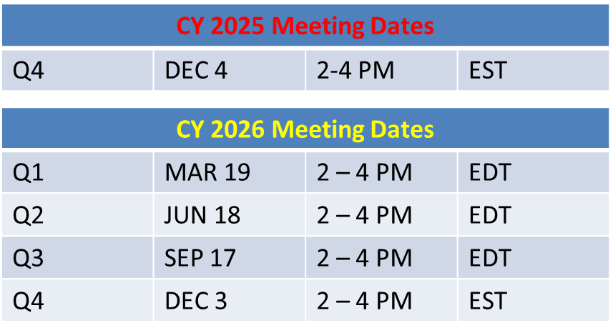

- Action Items:

- Discussion:
Mr. Paul Wormeli, newly elected PGB Chair outlined 2 alternative business model for NIEMOpen going forward describing the challenges and opportunities of each.

- Attachments:
- (FINAL) 28 August 2025 PGB Mtg Brief
- (Approved) NIEMOpen PGB Meeting Minutes 29 May 25
9. Minutes Approval: 28 August 2025 Meeting Minutes pending review and approval by PGB.

Distribution: https://lists.oasis-open-projects.org/g/niemopen-pgb , https://github.com/niemopen/oasis-open-project/tree/main/pgb-meeting-minutes

